COUNCIL NEWS

'We're paying for it': Push for mass transit consultation
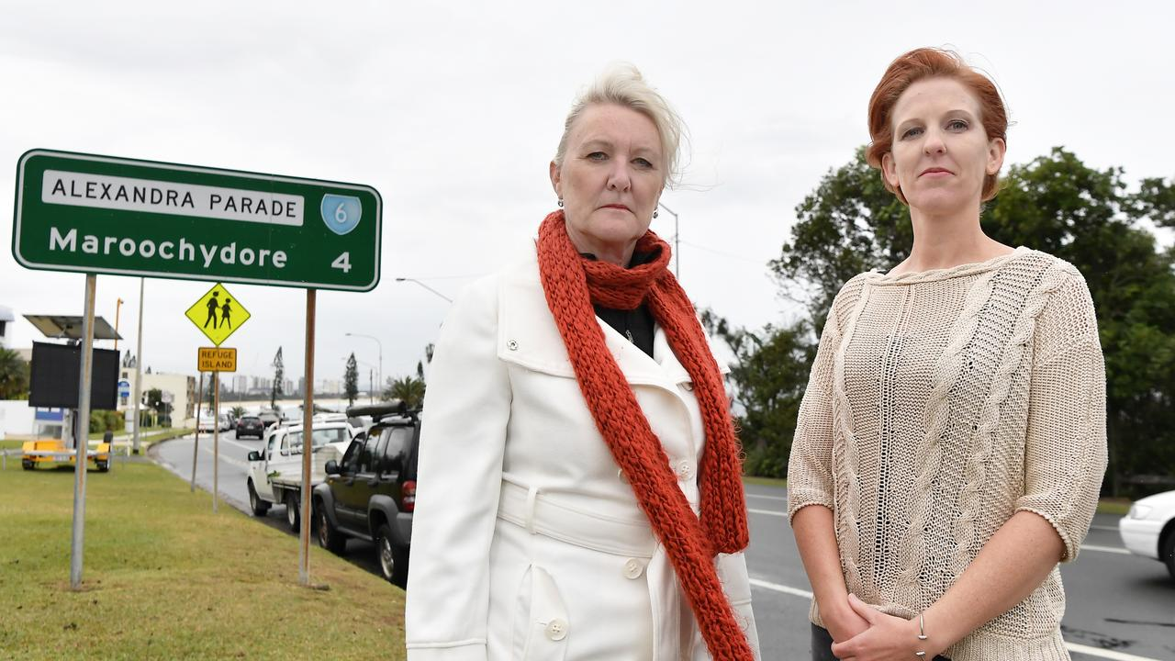
Tracey Goodwin-McDonald and Kate Harvey, from the Mass Transit Action Group, are calling on all Coast residents to contact councillors and let them know they want to have a say about the light rail/rapid bus mass transit plans. Photo Patrick Woods / Sunshine Coast Daily.
SCOTT SAWYER
24th Jul 2020 8:30 AM | Updated: 10:14 AM
A community action group has formed in a bid to force Sunshine Coast Council into greater consultation over a future light rail system and associated development.
The Mass Transit Action Group (Mtag) has been formed as efforts ramp up to have more community input into the major public transport project before its business case was progressed.
Kate Harvey and Tracey Goodwin-McDonald, two of the founding members of the group, which is hoped will be representative of views across the entire region, not just those in the mass transit corridor, said they were calling for residents to email their views on the project to councillors.
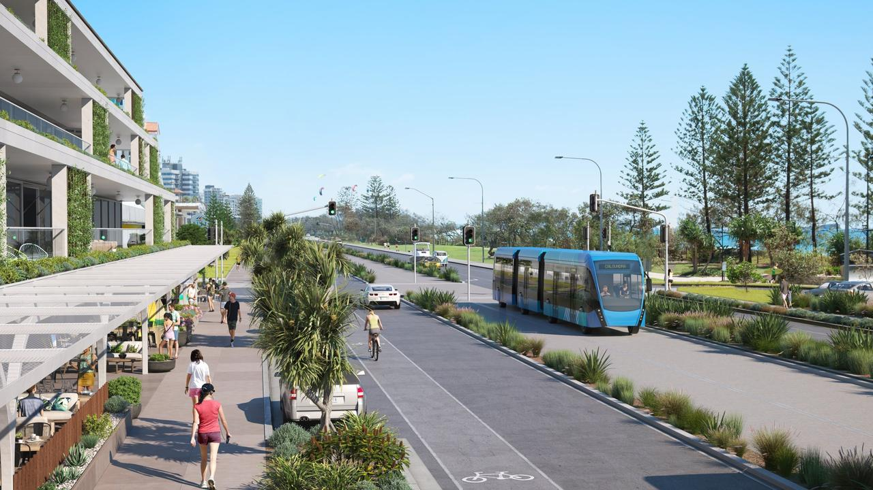
Sunshine Coast Council has revealed concept designs of transport options for the Sunshine Coast Mass Transit Plan.
Ms Goodwin-McDonald said everybody they'd spoken to thought the project was about introducing light rail into the region as-is, and many were unaware of the increased population and density of infill development associated with the project along the proposed corridor, to make the system viable.
She said they were concerned there wouldn't be adequate public consultation before the project was progressed further, by way of a detailed business case.
They were expecting the preliminary business case for the proposal, which is for a mass transit system from Maroochydore to Caloundra delivered in stages, to be put to council in August.
They also expected it to be adopted and progressed to a detailed business case process, which they feared would be too late for the community to have any real input.
"Nobody's talking about this because no one knows what it really means," Ms Goodwin-McDonald said.
She said it was a whole of region issue.
"It does impact people beyond who live here (in the corridor)," Ms Goodwin-McDonald said.
"We're all going to pay for it," Ms Harvey said.
The pair praised council for "doing the right thing addressing congestion and population growth", but they said a light rail system "wasn't right" and the community needed to have a say before it got to a detailed business case.
In a statement earlier this month, after Cr Joe Natoli voiced his fears about the mass transit plans, Mayor Mark Jamieson said further community engagement would be undertaken as part of the development of the detailed business case.
He said "extensive community engagement" associated with a potential light rail route had been undertaken in 2014.
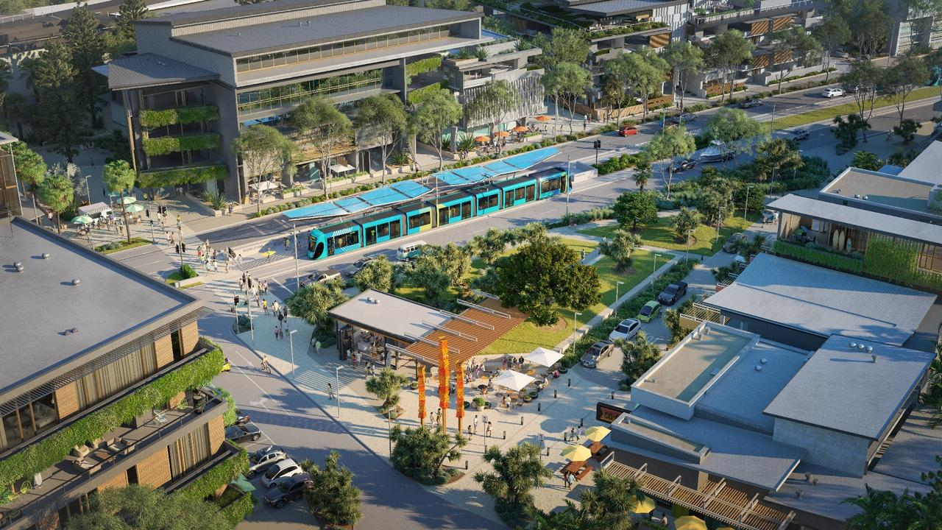
Sunshine Coast Council has revealed concept designs of transport options for the Sunshine Coast Mass Transit Plan.
Cr Jamieson said all information associated with the stages of the business case development that had been developed to-date were all publicly available.
A detailed business case, jointly funded by the State Government and council, was due to commence later this year.
"At the end of the day, public transport is a state government responsibility, but council has an important role to play in doing the planning work to encourage the necessary investment by government," Cr Jamieson said earlier this month.
"If we do not do so, then there is little likelihood that any substantive and efficient public transport solution will be delivered, in what is the second fastest growing region in the state.
"Alternatively, council could sit on its hands and do nothing other than propose simplistic and non-viable solutions that at the end of the day, the State Government would never consider."
For more about the new action group head to masstransitsc.com.

